## Lab 1: Ohm’s Law, KVL, and Voltage Divider Rule using Series Circuit

#### Objectives

* Find the resistance of a resistor from its color code.
* Measure voltage, current and resistance values using a digital multimeter.
* Verify the validity of Ohm’s Law.
* Test the voltage divider rule in a series circuit.

#### Introduction

The digital multimeter (DMM) is one of the most useful devices to measure voltage, current and resistance. Most DMMs have three terminals and two probes.

* + 1. One black terminal - zero potential/ Ground
    2. One red terminal - for measuring voltage
    3. One red terminal - for measuring current

One probe is continuously connected to the black terminal and another probe connects to one of the two red terminals depending on the measurement mode. Some advanced DMMs can also measure capacitance, inductance, detect terminals of transistors, diodes, etc.

PRECAUTION

To avoid damage of the DMM:

* keep it switched off while not in use.
* before connecting the DMM, the measurement mode must be selected and its meter range should be placed to its highest value.
* the red probe must be connected to the correct terminal.

#### Theoretical Background

Ohm’s Law Voltage Divider

Resistor Color Code Breadboard

DMM

Percentage Error

#### Voltage Measurement

Voltage is measured across the circuit elements / components. That is - a parallel connection is made with DMM and the desired element. Voltage measurement requires negative and positive polarity consideration. If the reading gives a positive value the the polarity consideration is correct.

#### Current Measurement

Current is measured through the circuit components. So, current measurement requires series connection with the DMM. Current measurement also requires polarity consideration. Similar to voltage measurement a positive reading will indicate right current flow consideration.

#### Resistance Measurement

Resistances are the simplest form of circuit components. Commercially resistors come in many shapes, sizes. Most common types of resistors are color-coded carbon composition or ~~cabin~~ CARBON film resistors. Color codes are multi-colored bands that determine the resistor’s value and tolerance. To measure the resistance two probes of DMM are connected to the two ends of the resistor. Again, resistance mode (Ohmmeter) must be selected before starting measurement.

PRECAUTION

Do not connect an Ohmmeter to a live circuit.

Only connect the component of which the resistance is to be measured.

Another way of measuring resistance is reading color codes (printed colored rings) on the resistors. Please refer to your textbooks of using this method.

* 1. Apparatus

1. Trainer board
2. LED
3. Resistors (1 KΩ, 3.3 KΩ, 4.7 KΩ, 10 KΩ)
4. Digital Multimeter (DMM)
   1. Breadboard [(http://wi](http://wiring.org.co/learning/tutorials/breadboard/))r[ing.org.co/learning/tutorials/breadboard/)](http://wiring.org.co/learning/tutorials/breadboard/))

A breadboard is a solderless device for temporary prototype with electronics and test circuit designs. Most electronic components in electronic circuits can be interconnected by inserting their leads or terminals into the holes and then making connections through wires where appropriate. The breadboard has strips of metal underneath the board and connect the holes on the top of the board. The metal strips are laid out as shown below. Note that the top and bottom rows of holes are connected horizontally and split in the middle while the remaining holes are connected vertically.

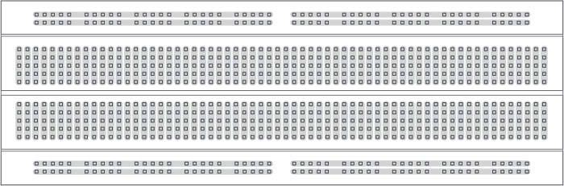

**Fig 1**

The top and bottom of a breadboard are shown below with the bottom insulation stripped off to clearly show metal strip connections corresponding to the holes. Please note that the orientation of the boards in the diagram below have been rotated by 90° compared to the diagram above.

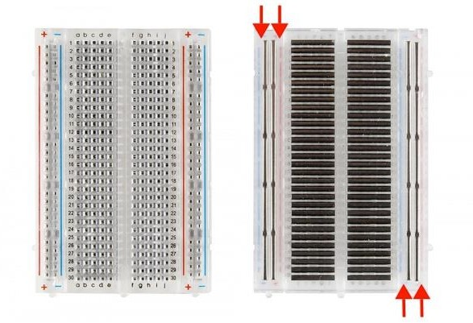

**Fig 2**

Note how all holes in the selected row are connected together, so the holes in the selected column. The set of connected holes can be called a node:

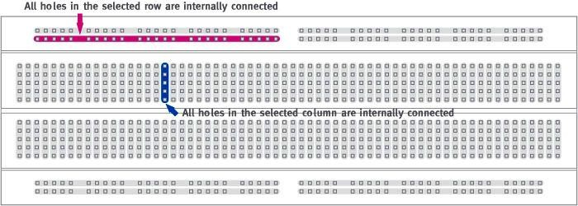

**Fig 3**

To interconnect the selected row (node A) and column (node B) a cable going from any hole in the row to any hole in the column is needed:

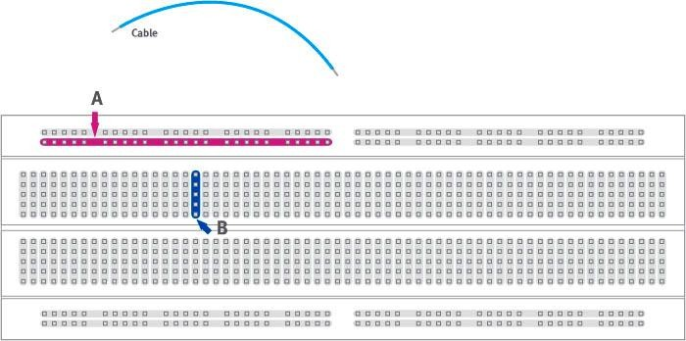

**Fig 4**

Now the selected column (node B) and row (node A) are interconnected:

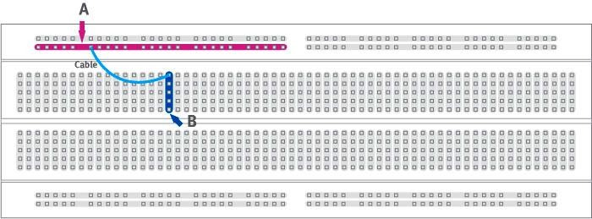

**Fig 5**

#### From electronic diagrams to actual circuit connections

(<http://wiring.org.co/learning/tutorials/diagrams/index.html)>

1. Trainer board
2. LED
3. 1kΩ Resistor
4. Digital Multimeter (DMM)

A circuit diagram makes use of standardized symbols that represent electrical components or devices. It is easier to draw these symbols than drawing the actual pictures of the components. The actual components might change appearance as the electronics industry revises them or renders them obsolete. The diagrams describe the way in which the components are connected together electrically. There are drawn lines that represent wires or conductors between the appropriate connection points on the symbols; no particular type of wire or physical distance between components is implied; two components might be separated by a few inches or centimeters or a meter or feet.

The following tutorial translates from a circuit diagram to actually connecting components on a breadboard. Note that the circuit diagrams are the universal way of representing circuits; books, on-line resources, and materials use them to communicate the circuit connections. They are very useful compared with pictorial diagrams of the connections.

Let us consider the following circuit diagram:

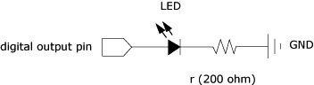

**Fig 6**

The next step would be to identify the components and their terminals:

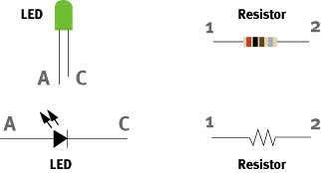

**Fig 7**

Next, identify the connection nodes between components, connections between different components are formed by putting their legs (or terminals) in a common node:

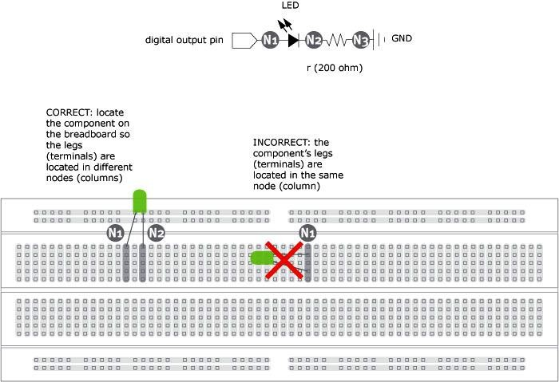

**Fig 8**

Note the difference between the correct and incorrect connections. In the correct version the two legs are on different columns (nodes), in the incorrect version the two legs are connected to the same column (node) which is equivalent to solder or tie together the two legs of the LED.

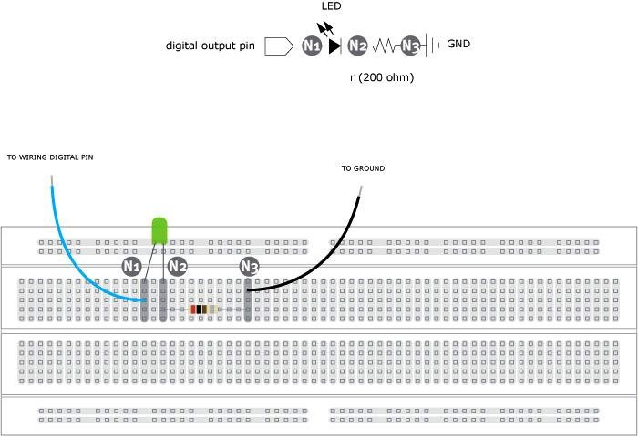

**Fig 9**

The LED has two legs, from Fig 7 the leg marked as A is connected to Node N1, the leg marked C is connected to the leg marked 1 on the resistor (Node N2) and the leg marked 2 on the resistor is connected to GROUND (Node N3). The LED is a polarized device, which means it matters the way it is connected, the resistor is not polarized so pins can be inverted with no effect on the circuit's behavior. To learn more about a specific component try to find its datasheet. Search on the Web using the component's reference number to become familiar with its functions, terminals and specs.

#### Equivalent resistance:

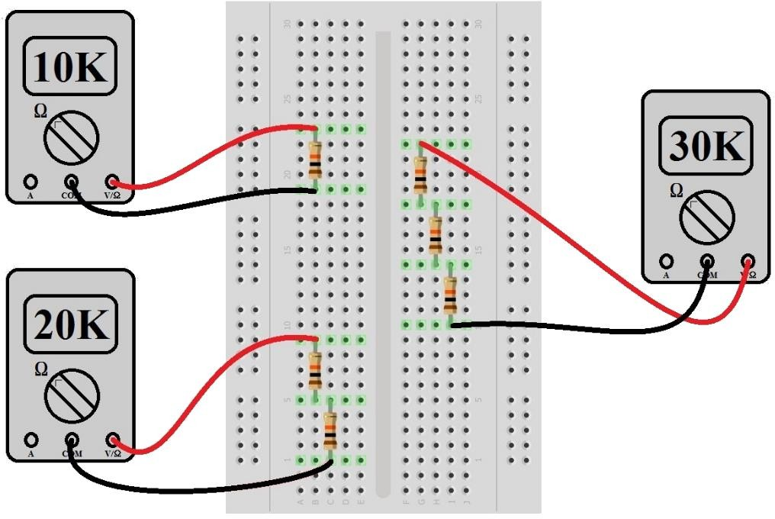Series:

Parallel:

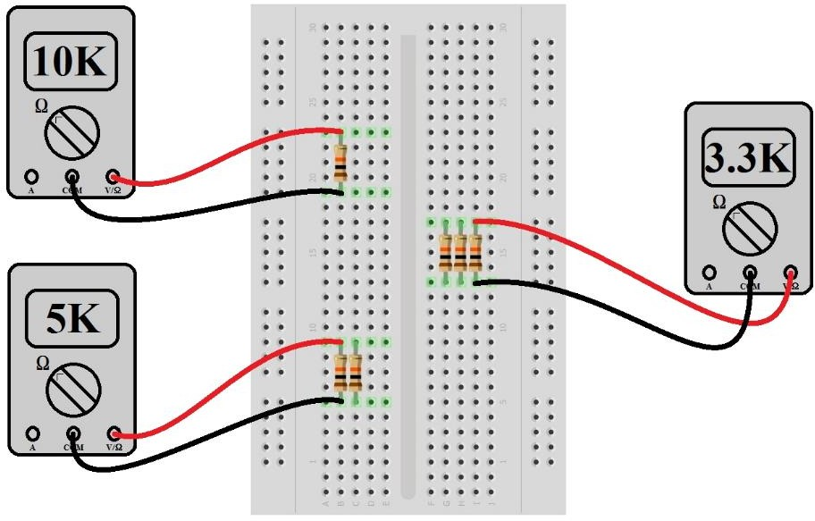

Source: https://learn.sparkfun.com/tutorials/series-and-parallel-circuits

**Exp1: Verification of Ohm’s Law**

#### Circuit Diagram:

**Circuit 1**

**List of Components:**

* Trainer board
* Resistors (3.3 KΩ, 5.6 KΩ)
* Digital Multimeter (DMM)
* Connecting Wire

**Procedure:**

* 1. Identify the given resistors using color coding and fill in the required columns in Table 1.
  2. Measure the resistances of the resistors using the DMM and fill in the required column in Table 1.
  3. Calculate the percentage error of the resistance values.

Percentage Error = |(Practical value – Theoretical value)| / Theoretical value

* 1. Build Circuit 1 using the 3.3 KΩ resistor.
  2. Set the voltage source to 2 V. Check the voltage across the supply using the DMM. Open circuit before taking source voltage reading to avoid loading effect of internal resistance.
     1. Measure the current flowing through the resistor. Note it down in Table 2.
     2. Calculate IR using the experimental values of I and R. Note it down in Table 2.
     3. Calculate the power using the experimental values of I and R (Power = I2R).
     4. Repeat the above steps for 2 V to 10 V in steps of 2 V (2 V, 4 V, 6 V, 8 V, 10 V).
  3. Repeat step 5-7 for the 5.6K resistor. Record data in Table 3

Data Collection for Exp1:

Lab 1: Exp1

Group No.

Instructor’s Signature

Table 1:

|  |  |  |  |  |  |  |
| --- | --- | --- | --- | --- | --- | --- |
| **Resistance using colour coding** | | | | | **Resistance using DMM** | **% Error** |
| **Band 1** | **Band 2** | **Band 3** | **Band 4** | **Resistance ± tol** |
| Orange | Orange | Red | Gold |  | 3.3k |  |
| Green | Blue | Red | Gold |  | 5.6k |  |

Table 2:

|  |  |  |  |
| --- | --- | --- | --- |
| **3.3 KΩ Voltage** | **Experimental readings** | | |
| **Current, I(mA)** | **Voltage, I R(V)** | **Power,**  I2R |
| 2 | 0.60596 | (0.60596m x 3.3k)=1.99 |  |
| 4 | 1.21 |  |  |
| 6 |  |  |  |
| 8 |  |  |  |
| 10 |  |  |  |

Table 3

|  |  |  |  |
| --- | --- | --- | --- |
| **5.6 KΩ Voltage** | **Experimental readings** | | |
| **Current, I** | **Voltage, I R** | **Power,**  I2R |
| 2 |  |  |  |
| 4 |  |  |  |
| 6 |  |  |  |
| 8 |  |  |  |
| 10 |  |  |  |

### Exp 2: Series Circuit

**Objectives**

* Learn how to connect a series circuit on a breadboard.
* Validate the voltage divider rules.
* Verify Kirchhoff’s voltage law.

**List of Components:**

1. Trainer board
2. Resistors (3.3 KΩ, 4.7 KΩ, 5.6K)
3. Digital Multimeter (DMM)
4. Connecting Wire

**Circuit Diagram:**

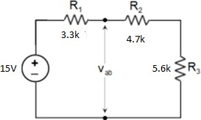

Circuit 2

Procedure:

1. Identify the given resistors using color coding and fill in the required columns in Table 1.
2. Measure the resistances of the resistors using the DMM and fill in the required column in Table 1.
3. Calculate the percentage error of the resistance values.

Percentage Error = |(Practical value – Theoretical value)| / Theoretical value

1. Build the Circuit 2.
2. Using the DMM, find the potential differences across the source VS and resistors R1, R2 and R3. Record the readings in Table 2.
3. Fill in Table 3.
4. Measure Vab. Calculate Vab using voltage division rule. Note down values in Table 4.
5. Now, disconnect the voltage source from the circuit and measure the total load resistance, Req of the circuit using DMM. Note down values in Table 4.

Data Collection for Exp2:

Lab 1: Exp2

Group No.

Instructor’s Signature

Table 1:

|  |  |  |  |  |  |  |
| --- | --- | --- | --- | --- | --- | --- |
| **Resistance using colour coding** | | | | | **Resistance using DMM** | **% Error** |
| **Band 1** | **Band 2** | **Band 3** | **Band 4** | **Resistance ± tol** |
| Orange | Orange | Red | Gold | 5% | 3.3k | 0 |
| Yellow | Violet | Red | Gold | 5% | 4.7k | 0 |
| Green | Blue | Red | Gold | 5% | 5.6k | 0 |
|  |  |  |  |  |  |  |

Table 2:

|  |  |  |  |  |  |  |  |
| --- | --- | --- | --- | --- | --- | --- | --- |
| **Experimental readings** | | | | **Theoretical values** | | | |
| **VS** | **VR1** | **VR2** | **VR3** | **VS** | **VR1** | **VR2** | **VR3** |
| 15 | 3.64 | 5.184 | 6.176 |  |  |  |  |
| **% Error** | | | | | | | |
| **VS** | | **VR1** | | **VR2** | | **VR3** | |
|  | |  | |  | |  | |

Table 3:

|  |  |  |
| --- | --- | --- |
| **Potential rise VS** | 15V | **Are the voltage rises and drops equal?** |
| **Potential drops (VR1 + VR2 + VR3)** | 3.64+5.184+6.176=15V | Yes |

Table 4

|  |  |  |  |
| --- | --- | --- | --- |
| **Experimental readings** | | **Theoretical values** | |
| **Vab** | **Req** | **Vab** | **Req** |
| 11.36 | 2.499k |  |  |
| % Error | | | |

|  |  |
| --- | --- |
| **Vab** | **Req** |
|  |  |

### Report

Experiment 1:

1. State Ohm’s law.
2. Plot V vs I graph for each resistor value in same graph.
3. Does your experimental circuit follow ohm’s law? Explain how did you figure it out.
4. Calculate the resistance of each circuit using the slope of your V vs I graphs. Compare these Rgraph values to the measured R values using DMM. Find the percent difference.

**Experiment 2:**

1. State the voltage division rule.
2. State the Kirchhoff’s voltage law (KVL).
3. Showing all steps, calculate the theoretical values in Table 2. Compare theoretical values to your experimental values and explain whether your circuit follows KVL or not.
4. Showing all the calculations, theoretically calculate Vab. Compare with the experimental value and verify the voltage division rule at the terminal a-b.
5. Showing all the steps, calculate Req. Compare with the experimental value.

**Useful Formula:**

Voltage Divider Rule: VX = E RX / RT

% Error = (Theoretical value – Experimental Value) / Theoretical Value

**Lab 2: KCL, Current Divider Rule with Parallel and Ladder Circuit.**

**Objectives**

* Learn how to connect a parallel circuit on a breadboard.
* Validate the current divider rules.
* Verify Kirchhoff’s current law.
* Verify KCL and KVL in ladder circuit.

### List of Components:

* Trainer board
* Resistors (1K, 3.3 KΩ, 4.7 KΩ, 5.6K, 10K)
* Digital Multimeter (DMM)
* Connecting Wire

### Circuit Diagram:

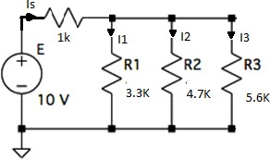

Circuit 1

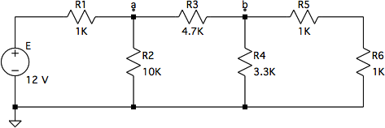

### Procedure:

Circuit 2

1. Identify all the given resistors using color coding and fill in the required columns in Table 1.
2. Measure the resistances of the resistors using the DMM and fill in the required column in Table 1.
3. Calculate the percentage error of the resistance values.
4. Percentage Error = |(Practical value – Theoretical value)| / Theoretical value
5. Build the circuit 1
6. Using the DMM, measure the currents Is, I1, I2, and I3. Record the readings in Table 2.
7. Fill in Table 3.
8. Now, disconnect the voltage source from the circuit and measure the total load resistance, Req of the circuit using DMM. Note down values in Table 4.
9. Construct Circuit 2.
10. Using a DMM, measure the potential differences across all the resistors in circuit 2. Record all the readings in Table 5
11. Using a DMM, measure the current through all the resistors and record in Table 5.

Data Collection

Lab 2

Group No.

Instructor’s Signature

Table 1:

|  |  |  |  |  |  |  |
| --- | --- | --- | --- | --- | --- | --- |
| **Resistance using colour coding** | | | | | **Resistance using DMM** | **% Error** |
| **Band 1** | **Band 2** | **Band 3** | **Band 4** | **Resistance ± tol** |
|  |  |  |  |  |  |  |
|  |  |  |  |  |  |  |
|  |  |  |  |  |  |  |
|  |  |  |  |  |  |  |
|  |  |  |  |  |  |  |
|  |  |  |  |  |  |  |

Table 2:

|  |  |  |  |  |  |  |  |
| --- | --- | --- | --- | --- | --- | --- | --- |
| **Experimental readings** | | | | **Theoretical values** | | | |
| **IS** | **IR1** | **IR2** | **IR3** | **IS** | **IR1** | **IR2** | **IR3** |
| 4.1mA | 1.788mA | 1.256mA | 1.053mA |  |  |  |  |
| **% Error** | | | | | | | |
| **IS** | | **IR1** | | **IR2** | | **IR3** | |
|  | |  | |  | |  | |

Table 3:

|  |  |  |
| --- | --- | --- |
| **IS** |  | **Is Total Current equal to sum individual current?** |
| **Sum of individual Current (IR1 + IR1 + IR3)** | 4.097mA | Yes |

Table 4:

|  |  |  |
| --- | --- | --- |
| **Experimental Req** | **Theoretical Req** | **% Error** |
| 2.44k | 2.44k |  |

Table 5:

|  |  |  |
| --- | --- | --- |
| **Component** | **Voltage** | **Current** |
| **E** | 12V | 2.537mA |
| **R1** | 2.536V | 2.537mA |
| **R2** | 9.464V | 0.945mA |
| **R3** | 7.481V | 1.592mA |
| **R4** | 1.982V | 0.601mA |
| **R5** | 0.991V | 0.991mA |
| **R6** | 0.991V | 0.991mA |

#### Report

1. State the current division rule.
2. State the Kirchhoff’s current law (KCL).
3. With the experimental data, verify Kirchhoff’s voltage law within each independent closed loop of the circuit.
4. With the experimental data, verify Kirchhoff’s current law at nodes *a* and *b* of the circuit.
5. Showing all steps, calculate the theoretical values in Table 2. Compare theoretical values to your experimental values and explain whether your circuit follows KCL or not.
6. Showing all the steps, theoretically calculate Req. Compare with the experimental value.
7. Calculate all the theoretical values for Table 5. Show all steps.

**Useful Formula:**

Current Divider Rule : IX = Is RT / RX

% Error = (Theoretical value – Experimental Value) / Theoretical Value

## Lab 3: Loading Effect of Voltage Divider Circuit

### Objective:

#### To analyze how the voltage divider circuit behaves when there is no load resistance connected.

* + Evaluate the performance of voltage divider circuit due to loading.

**List of Equipment:**

* + Trainer Board
  + DMM
  + 2 × 560Ω resistors
  + 1 × (0-10kΩ) variable resistor/RHEOSTAT

### Introduction:

#### Voltage Divider circuit provides a simple way to convert a DC voltage to another lower DC voltage.

Consider the following voltage divider circuit.

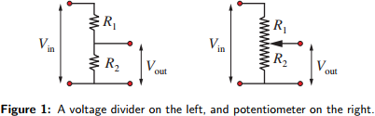

The voltage drop across R2 is the output voltage, Vout. Vout is less than Vin because the total voltage across R1 and R2 must add up to Vin. A potentiometer can also be used to change Vout by changing the resistance R2. As the value of R2 is changed, it allows the output voltage to be adjusted from 0 to Vin.

In Figure 1, there is no output load (𝑅𝐿) connected in parallel to 𝑅2 hence we call it a No-Load circuit.

According to Voltage Divider Rule: 𝑽

𝒐𝒖𝒕

#### = 𝑽

𝑹𝟐

𝒊𝒏 𝑹𝟏+ 𝑹𝟐

(1)

* **Say Vin=5v and you need Vout= 3v. How would you set the values of** 𝑹𝟏 **and** 𝑹𝟐 **?**

𝑉𝑜𝑢𝑡 = 𝑅2

𝑉𝑖𝑛

𝑅1 + 𝑅2

#### Choice of resistor value should follow the ratio: 𝑅1 = 2

𝑅2 3

#### One possible combination: 𝑅1 = 2𝑘 𝑎𝑛𝑑 𝑅2= 3k

* **Now say we connect an output load,** 𝑹𝟑 **in parallel to** 𝑹𝟐 **:**

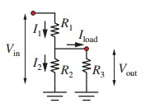

Figure 2: With Output Load Connected.

#### ⟹ Do you think keeping the values of resistors same would still give Vout=3v from Vin=5v? Let’s check:

Since you have a Load resistance parallel to 𝑅2 , your Voltage divider formula to find Vout is:

𝑽𝒐𝒖𝒕

#### = 𝑽

(𝑹𝟐 ∕∕𝑹𝟑)

𝒊𝒏 𝑹𝟏+(𝑹𝟐 ∕∕𝑹𝟑)

(2)

#### Let 𝑅3 = 10k.

𝑅2 ∕∕ 𝑅3 = 2.31k

→ 𝑉𝑜𝑢𝑡 = 2.68 𝑣

#### So, our Designed value was 3v, but connecting a load resistor reduced it to 2.68v.

**Design Criteria:**

To minimize the loading effect, choose the load resistor to be much larger than its parallel resistor.

If 𝑅3 is much greater than 𝑅2 then 𝑅2 ∕∕ 𝑅3 (parallel combination of 𝑅2 𝑎𝑛𝑑 𝑅3 ) is approximately equal to 𝑅2

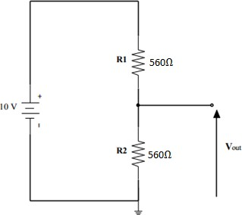**Circuit Diagram:**

**Procedure:**

1. Construct the voltage divider circuit as shown in figure above.
2. Measure the unloaded output voltage Vout. Record the value in Table 1.
3. Connect 10 kΩ variable load resistor, parallel with R2 to the circuit. (Connect 1 middle pin of variable resistor and one of the other pins).
4. Change the value of the variable resistor according to Table 1, and record Vout for each resistor value in Table 1.

### Data Collection for Lab 3:

Group No. Instructor’s Signature

Table 1:

|  |  |  |  |
| --- | --- | --- | --- |
| **RL** | **Vout(V) (Measured)** | **Vout(V) (Calculated)** | **%Error** |
| **No resistor** | 5 | 5 | 0 |
| **1k** | 3.906 | 3.9062 |  |
| **4k** | 4.673 | 4.6728 |  |
| **7k** | 4.808 | 4.8077 |  |
| **10k** | 4.864 | 4.8638 |  |

### Report Question:

#### Explain the loading effect of your circuit (i.e explain how does your Vout vary with increasing Load resistor)

1. Showing all steps in details, theoretically calculate the value of Vout for each load resistor.
2. Comparing the theoretical data to the experimental data, comment how far the loading effect of your circuit supports the theory.

Lab 4: Verification of Superposition Theorem.

**Objective:**

* To verify Superposition Theorem.

**List of Equipment**

* Trainer Board
* DMM
* 1 x 3.3kΩ resistor
* 1 x 4.7kΩ resistor
* 1 x 1KΩ resistor

### Circuit Diagram

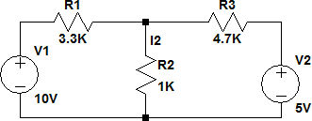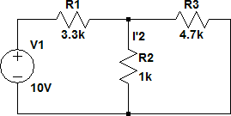

Circuit 1 Circuit 2

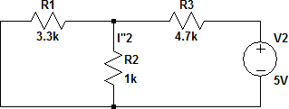

### Procedure:

Circuit 3

1. Set up Circuit 1.
2. Mark the polarities of each resistor.
3. With both the voltage source connected to the circuit, measure 𝐼2 , 𝑉𝑅1, 𝑉𝑅2, 𝑉𝑅3 and record the values in appropriate tables.
4. Setup Circuit 2. Measure and record 𝐼′2, 𝑉′𝑅1, 𝑉′𝑅2, 𝑉′𝑅3.

5. Setup Circuit 3. Measure and record 𝐼′′2, 𝑉′′𝑅1, 𝑉′′𝑅2, 𝑉′′𝑅3.

Data Collection for Lab 4:

Group No.

Instructor’s Signature

Table 1:

|  |  |  |  |
| --- | --- | --- | --- |
| **I2** | **I’2** | **I”2** | **I’2 + I”2** |
| 2.701mA | 1.999mA | 0.702mA | 2.701mA |

Table 2:

|  |  |  |  |
| --- | --- | --- | --- |
| **VR1** | **V’R1** | **V’’R1** | **V’R1+ V’’R1** |
| 7.299V | 8.001V | -0.702V | 7.299V |

Table 3:

|  |  |  |  |
| --- | --- | --- | --- |
| **VR2** | **V’R2** | **V’’R2** | **V’R2+ V’’R2** |
| 2.701V | 1.999V | 0.702V | 2.701V |

Table 4:

|  |  |  |  |
| --- | --- | --- | --- |
| **VR3** | **V’R3** | **V’’R3** | **V’R3+ V’’R3** |
| -2.299V | 1.999V | -4.298V | -2.299V |

### Report:

#### What is Superposition Theorem?

1. Theoretically Calculate all values of Table 1 to Table 4. **Show all the steps in details.**

#### Using measured data, show that your circuit followed superposition theorem.

1. Find the % Error between your theoretical and experimental values.

Lab 5: Delta-Wye Conversion

**Objectives:**

1. To perform Delta-Wye Conversion
2. To verify the results with measured data.
3. Solve a complex circuit using Delta-Wye Conversion.

The Delta-Wye transformation is an extra technique for transforming certain resistor combinations that cannot be handled by the series and parallel equations. This is also referred to as a Pi - T transformation

Sometimes when you are simplifying a resistor network, you get stuck. Some resistor networks cannot be simplified using the usual series and parallel combinations. This situation can often be handled by trying ∆ − 𝑌 transformation, or 'Delta-Wye' transformation.

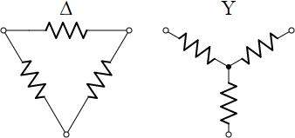The names Delta and Wye come from the shape of the schematics, which resemble letters. The transformation allows you to replace three resistors in a Δ configuration by three resistors in a Y configuration, and the other way around.

The ∆ − 𝑌 drawing style emphasizes these are 3-terminal configurations. Something to notice is the different number of nodes in the two configurations. Δ has three nodes, while Y has four nodes (one extra in the center).

The configurations can be redrawn to square up the resistors. This is called *π*−T configuration,

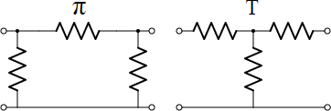

The π−T style is a more conventional drawing you would find in a typical schematic. The transformation equations developed next apply to π−T as well.

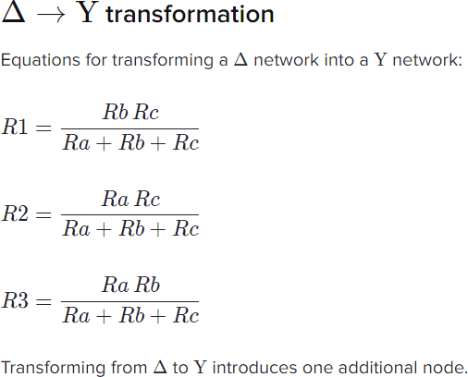

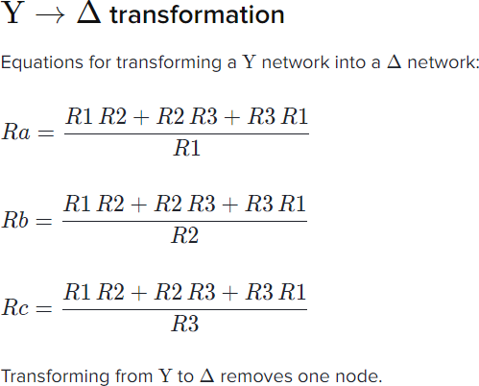

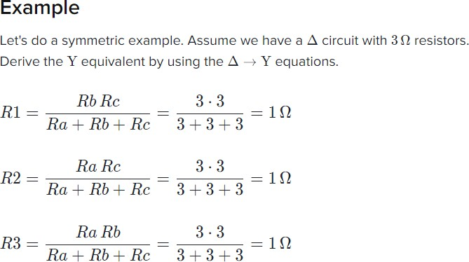

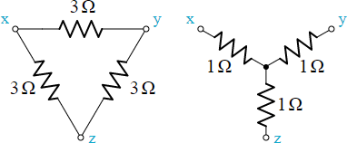

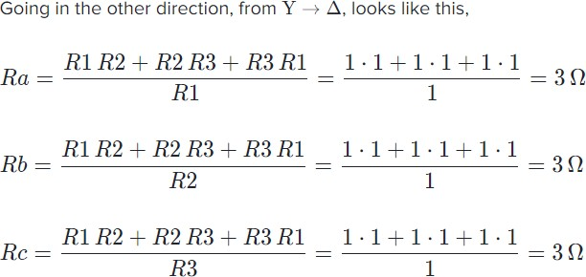

The transformed network and the original network has the same equivalent resistance (although the individual resistors between the nodes are different). The two networks will be electrically identical as measured from the three terminals (A, B, and C). i.e The node voltages of both the circuits would be equal.

**Circuit Diagram:**

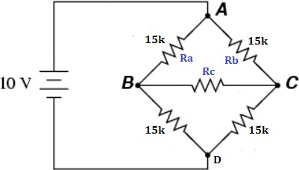

Circuit 1

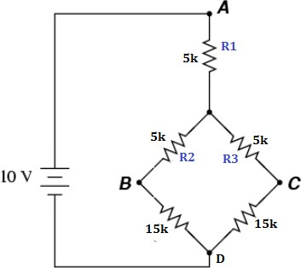

Circuit 2

**List of Equipment**

* Trainer Board
* DMM
* 5 x 15kΩ resistor
* 3 x 5 kΩ resistor

**Procedure**

1. Measure the resistor values with DMM and note down in Table 1.
2. Setup the circuit as shown in the circuit 1
3. Measure the voltage 𝑉𝐴𝐷 , 𝑉𝐵𝐷, 𝑉𝐶𝐷 (D is the reference node) and note down in Table 2
4. Measure the voltage 𝑉𝐴𝐵 , 𝑉𝐵𝐶, 𝑉𝐴𝐶 and note down in Table 2
5. Setup Circuit 2.
6. Measure the voltage 𝑉𝐴𝐷 , 𝑉𝐵𝐷, 𝑉𝐶𝐷 (D is the reference node) and note down in Table 2
7. Measure the voltage 𝑉𝐴𝐵 , 𝑉𝐵𝐶, 𝑉𝐴𝐶 and note down in Table 2

### Data Collection for Lab 5:

**Group No.**

**Instructor’s Signature**

Table 1:

|  |  |  |
| --- | --- | --- |
| Theoretical R | Measured R | % Error |
| 15k |  |  |
| 5k |  |  |

Table 2:

|  |  |  |  |
| --- | --- | --- | --- |
| Readings | Circuit 1 | Circuit 2 | % Error |
| 𝑉𝐴𝐷 | 10 |  |  |
| 𝑉𝐵𝐷 | 5 |  |  |
| 𝑉𝐶𝐷 | 5 |  |  |
| 𝑉𝐴𝐵 | 5 |  |  |
| 𝑉𝐵𝐶 | 0 |  |  |
| 𝑉𝐴𝐶 | 5 |  |  |

**Report:**

1. The resistors in Circuit 1 are in series or in parallel combination?
2. What technique would you use to find the equivalent resistance?
3. Perform Delta-Wye conversion for ∆𝐴𝐵𝐶 (𝑢𝑝𝑝𝑒𝑟 𝑝𝑜𝑟𝑡𝑖𝑜𝑛) of circuit 1. Show all your steps to find the equivalent resistance R1, R2, R3 from Ra, Rb, Rc.
4. Redraw the equivalent the circuit after applying the Delta-Wye conversion for ∆𝐴𝐵𝐶. Is it same as circuit 2?
5. Calculate Req.
6. Calculate the voltage of R1, R2, R3.
7. Calculate 𝑉𝐴𝐵 , 𝑉𝐵𝐶 , 𝑉𝐴𝐶 and 𝑉𝐴𝐷 , 𝑉𝐵𝐷, 𝑉𝐶𝐷. Do your calculated values match the measured values for circuit 2? Find the % Error.
8. Using Table 2, analyze whether Circuit 2 is equivalent to Circuit 1? Was Delta-Wye conversion successful?

**Lab 6: Verification of Thevenin’s, Norton’s and Maximum Power Transfer Theorem**

**Objectives**

* Experimentally perform Thevenin’s theorem, Norton’s theorem and Maximum Power theorem
* Perform theoretical calculations.
* Verify the experimental values with theoretical values.

**List of Components:**

* Trainer board
* 1× 1K
* 1× 5K
* 2 × 10KΩ
* POT (10K)
* Digital Multimeter (DMM)
* Connecting Wire

## Theory:

#### **Thevenin’s Theorem**: Thevenin’s Theorem states that it is possible to simplify any linear circuit, no matter how complex, to an equivalent circuit with just a single voltage source and series resistance connected to a load. The Thévenin equivalent circuit consists of a single dc source referred to as the Thévenin voltage (𝑉𝑇𝐻, E𝑇𝐻, 𝑉OC) and a single fixed resistor called the Thévenin resistance (𝑅𝑇𝐻)

**Norton’s Theorem:** Norton’s Theorem states that it is possible to simplify any linear circuit, no matter how complex, to an equivalent circuit with just a single current source (𝐼𝑁) and parallel resistance connected to a load (𝑅𝑁)

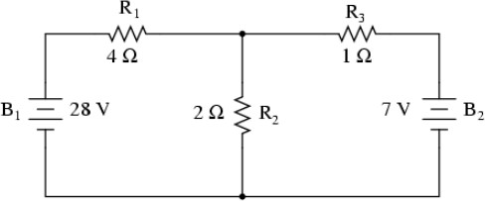Usefulness of Thevenin and Norton Theorem:

Let’s consider 𝑅2 as the load resistor. To find the voltage and current across this load resistor, you can follow superposition theorem. Now say your load resistance is subjected to change (i.e it varies), then each time your resistor value changes, you need to apply superposition theorem and recalculate the current and voltages. This is time consuming.

Thevenin’s or Norton’s theorem makes this easy by temporarily removing the load resistance from the original circuit and reducing what’s left to an equivalent circuit:

* Single voltage source and series resistance in case of Thevenin.
* Single current source and parallel resistance in case of Norton.

The load resistance can then be re-connected to this “equivalent circuit” and calculations carried out as if the whole network were nothing but a simple series circuit:

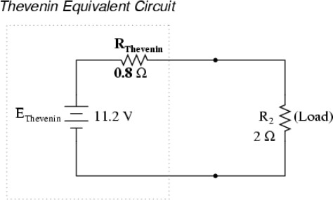

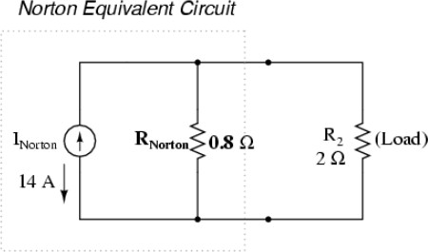

**How to find** 𝑬𝑻𝑯**?**

#### Remove the load resistance, calculate the open-circuit voltage at the terminals of the load

resistance.

**How to find** 𝑹𝑻𝑯**?**

#### With the load resistance still removed, remove the independent voltage sources (replace

them with a short circuit just like in superposition theorem) and calculate the resistance at the terminals of the load resistor.

**How to find** 𝑹𝑵**?**

#### Methods for finding 𝑅𝑁is same as that for 𝑅𝑇𝐻

**How to find** 𝑰𝑵**?**

#### With voltage sources turned on, replace the load resistance as short circuit. Measure the

short circuit current. This short circuit current is 𝐼𝑁.

**Thevenin Norton Equivalence:**

𝑅𝑁 = 𝑅𝑇𝐻

𝐸𝑇𝐻 = 𝐼𝑁 𝑅𝑇𝐻

## Maximum Power Theorem:

#### Maximum Power will be delivered to the load when that load resistance is equal to the Thevenin/Norton resistance of the network supplying the power. If the load resistance is lower or higher than the Thevenin/Norton resistance of the source network, its dissipated power will be less than maximum.

A load impedance that is too high will result in low power output. A load impedance that is too low will not only result in low power output

𝐼𝐿 = 𝑉𝑇𝐻 / ( 𝑅𝑇𝐻+ 𝑅𝐿)

= 𝑉𝑇𝐻 / (𝑅𝑇𝐻+ 𝑅𝑇𝐻)

= 𝑉𝑇𝐻 / 2 𝑅𝑇𝐻

Where**, Pmax** = 𝐼𝐿 2𝑅𝐿

=𝑉𝑇𝐻2 / 4 𝑅𝑇𝐻

## Circuit Diagram:

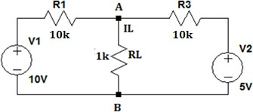

Procedure:

1. Measure the values of resistance using DMM.
2. Construct the Circuit-1
3. Measure 𝑉𝐿and 𝐼𝐿 of 𝑅𝐿 for circuit 1. Record in Table-2.
4. Remove 𝑅𝐿 from the original circuit and measure the open circuit voltage Vth.
5. Measure the short circuit current 𝐼𝑁 by placing an Ammeter between A and B. In this manner, the Ammeter will act as a short circuit.
6. Replace the voltage sources with short circuits. With RL removed from the circuit measure Rth using a multimeter (place DMM across A and B)
7. Record values in Table-3.
8. Draw the Thevenin and Norton Equivalent circuit in Table-4.
9. Construct the Thevenin equivalent circuit drawn in Table-4, measure 𝐼𝐿 and 𝑉𝐿. Record readings in Table 2.
10. Now replace the load resistor with a POT, vary the load resistance and for each resistance value measure

𝑉𝐿. Fill in Table-5

### Data Collection for Lab 6:

**Group No. Instructor’s Signature**

**Table 1:**

|  |  |  |
| --- | --- | --- |
| Theoretical R | Measured R | % Error |
| 5K |  |  |
| 1K |  |  |

**Table 2:**

|  |  |  |
| --- | --- | --- |
| Value | Measured R | % Error |
| 𝑉𝐿 | 1.25V |  |
| 𝐼𝐿 | 1.25mA |  |

**Table 3:**

|  |  |  |  |
| --- | --- | --- | --- |
| Measurement | Measured | Calculated | % Error |
| 𝑉𝑇𝐻 | 7.5V |  |  |
| 𝐼𝑁 | 1.5mA |  |  |
| 𝑅𝑇𝐻 | 5kohm |  |  |
| 𝑉𝐿 | 1.25V |  |  |
| 𝐼𝐿 | 1.25mA |  |  |

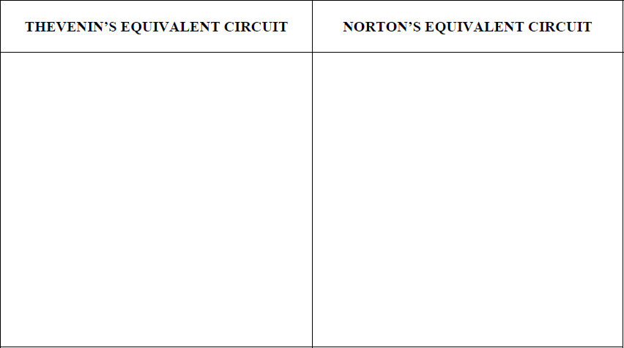**Table 4:**

**Table 5:**

|  |  |  |
| --- | --- | --- |
| RL (kΩ) | VL (Experimental) | PL (Experimental) |
| 1.0 | 1.25V | 1.563mW |
| 2.0 |  |  |
| 3.0 | 2.813V | 2.635mW |
| 4.0 |  |  |
| 5.0 | 3.75V | 2.81mW |
| 6.0 |  |  |
| 7.0 | 4.375V | 2.73mW |
| 8.0 |  |  |
| 9.0 |  |  |
| 10 | 5V | 2.5mW |

Report Questions:

1. Calculate all the theoretical values of Table 2. **Show all steps**
2. Comparing experimental values to theoretical values, verify Thevenin and Norton theorem.
3. Prove Thevenin Norton equivalence.
4. In a graph paper, draw 𝑃𝐿 vs 𝑅𝐿 .
5. From the graph state the value of 𝑅𝐿 for which maximum power is obtained.
6. Theoretically calculate the maximum power.
7. Verify the maximum power theorem

**Lab 7: Charging and Discharging of RC circuits**

### Objective:

#### To learn the use of Signal Generators and Oscilloscope.

* Investigate the behavior charging and discharging of RC circuits with changing Time Period, T of the input Square wave.

**Introduction:**

Time varying signal: A signal whose values changes with time.

Peak Voltage = maximum voltage of a signal. It is often denoted by **Vp**

Time period: Time required to complete 1 cycle. It is denoted by **T**.

Frequency: No. of cycles completed in 1 second. It is denoted by **f.** Its unit is in Hz.

Relationship between T and f:

**T= 1/f**

A few examples of Time varying signals:

1. Sin wave
2. Square wave
3. Triangular wave

A typical square wave looks like below:

V

V0

0 1 3 5 7 9 11 13 15 17 19 21 23 25 t T

#### V0 = maximum voltage (amplitude) T = Time period of the signal

**Signal generator** is a device that allows you to generate a time varying signal that have a particular frequency and amplitude (Vp). You can adjust your time period by adjusting your frequency.

**RC circuits**

**What is a Capacitor?**

Capacitor is an electronic component that stores electric charge.

**Capacitor construction:** The capacitor is made of 2 close conductors (usually plates) that are separated by a dielectric material, which is a poor conductor (or an insulator).

When the two plates are connected to power supply (one connected to positive polarity, other connected to negative polarity) An electric field is generated across the dielectric (between the plates) due to which one plate accumulates positive charge and the other plate accumulates negative charge. There is no direct flow of current from one plate to other.

The capacitance is the amount of electric charge that is stored in the capacitor at voltage of 1 Volt. It is measured in units of Farad (F).

The capacitor is open circuit to direct current (DC) circuits and short circuit in alternating current (AC) circuits.

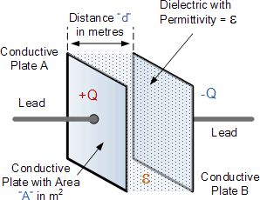𝐶 =

𝜖 𝐴

𝑑

𝑄 = 𝐶𝑉

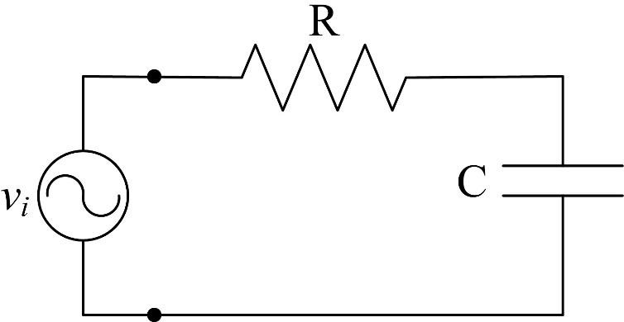Consider a series RC circuit with a time-varying input source (such as a square wave).

**RC charging:**

When the input is positive, the capacitor will charge up gradually through the resistor until the voltage across the capacitor reaches that of the supply voltage.

The time also called the transient response, required for the capacitor to fully charge is equivalent to about **5 time constants** or 5T.

τ = R x C, in seconds, where R is the value of the resistor in ohms and C is the value of the capacitor in Farads. This then forms the basis of an RC charging circuit were 5T can also be thought of as “5 x RC”.

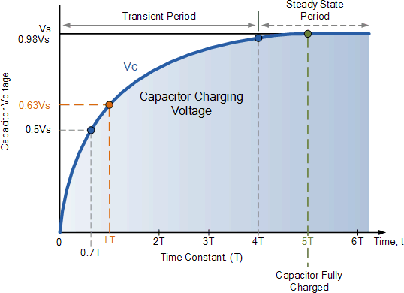

From the graph, understand what is 𝜏

#### Voltage, Vc across the capacitor varies with time according to the formula:

***V(t)* = *V*o (1 – e–*t/RC*),**

### RC Discharging:

#### Now, when the input signal becomes negative, the capacitor would start discharging itself back through the resistor.

For a RC discharging circuit, the voltage across the capacitor ( Vc ) as a function of time during the discharge period is defined as:

***V(t)* = *V*oe–*t/RC***

Where:

* Vc is the voltage across the capacitor
* Vs is the supply voltage
* t is the elapsed time since the removal of the supply voltage
* RC is the *time constant* of the RC discharging circuit

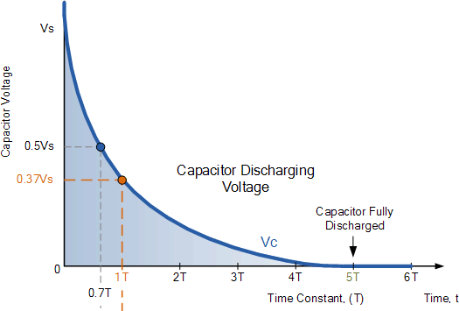

# How Does Time period, T of the input signal effects the charging- discharging of capacitor?

|  |
| --- |
| **When T=10RC** |
| Screen Clipping |
| **When T >> 5RC** |

|  |
| --- |
| Screen Clipping |
| **T < 5RC** |
| Screen Clipping |

##### 2 Methods to find 𝝉

**Method 1:**

* + Move your graph vertically up so that it is completely above the x-axis.
  + Calculate the voltage 0.63Vs (or 0.63Vc)
  + Put on the “cursor” and set the horizontal line at the voltage calculated.
  + Observe the point the cursor cuts the graph. Measure the corresponding time

**Method 2:**

An indirect method of finding the time constant, 𝜏 is by measuring the time required for the voltage to fall to *V*o /2. This time interval is called the half-life, *T*1/2 , and then calculate 𝜏 using the formula below:

|  |  |
| --- | --- |
| V  V0 10  8  6  1/2 V0  4  2  0  0 2 4 6 8 10 12 14 18 20 t  T1/2 | ⧫ = *T*1/2 /ln2  *=T*1/2 /(0.693) |

**Technique to find *T*1/2 from oscilloscope:**

• Change oscilloscope gain (volts/cm) and sweep rate (ms/cm) until you have a large pattern on the screen. Make sure the sweep speed is in the “calibrated” position so the time can be read off the *x*-axis.

* Set the ground properly so that the waveform extends equal distances above and below the axis.
* Move the waveform to the right until the start of the discharge of the capacitor is on the vertical axis (Figure 6b). You may find it helpful to expand, or magnify, the trace. The sweep time is now a factor of five or ten faster than indicated on the dial.
* The half-life, *T*1/2 is the time where the discharging phase cuts the x-axis.

T1/2

**Task 1: Using Signal Generator to generate Square Wave.**

Generate a square wave with frequency 100Hz and a 5v peak. Observe the pattern in the oscilloscope and vary the frequency until T=10ms.

What is the frequency value? f =

**Task 2: Construct an RC circuit such that R = 5k, C = 0.22uF. Input is a 10v(p-p) square wave.**

**Procedure:**

1. Calculate the value of input frequency such that T = 10RC
2. Adjust the frequency of the input signal to that calculated in part 1. Connect the Channel 1 of oscilloscope to the input signal. Adjust the input peak to peak value to 10v.Now connect channel 2 of oscilloscope with the capacitor.
3. Measure 𝜏 from the oscilloscope (Using any 1 of the methods explained above)
4. Measure the final output voltage of the capacitor, Vc
5. Measure the time the capacitor charges up to Vc.
6. Measure the time the capacitor starts to discharge
7. Measure the time the capacitor stops discharging
8. Calculate the input frequency such that T=30RC
9. Repeat steps 2-7.
10. Calculate the input frequency such that T= 3.5ms (T<5RC) 11.Repeat steps 2-7.

**Data Collection for Lab 7**

Group: Instructor’s Signature:

**Data Table:**

|  |  |  |  |
| --- | --- | --- | --- |
| **Measurement** | **T=10RC** | **T=30RC** | **T=3.5ms** |
| Frequency of input signal | 90.91 Hz | 30.30 Hz | 285.71 Hz |
| Time constant, 𝜏 | 1.08ms | 0.95ms |  |
| Final Output Vc | 10V | 10V |  |
| Measure the time the capacitor charges up to Vc | 5.5ms | 16.5ms |  |
| Time the capacitor starts to discharge | 5.5ms | 16.5ms |  |
| Time the capacitor stops discharging | 10.9ms | 21.99ms |  |

**Report:**

1. In separate graph papers, draw the charging-discharging phase for the RC circuit for 3 different values of T. **The graphs should be drawn using values from Table-1.**
2. Explain what is 𝜏 .
3. Theoretically calculate 𝜏 and compare with the measured value of 𝜏.
4. **Using the data table**, **explain in details** the charging-discharging pattern for all the 3 cases.